Python abs() Function: Absolute Value Examples

One of the reasons for the popularity of Python is its built-in functions. Python provides a large number of built-in functions. The is a function to find the absolute value of any number. While working with distance calculations we always need a positive number. As distance is always positive. Another example of usage of absolute value is speed calculations. Let’s take a look at how to use absolute value function in Python.

|  |
| --- |
| x = -9 print(abs(x)) |

The output is shown below.

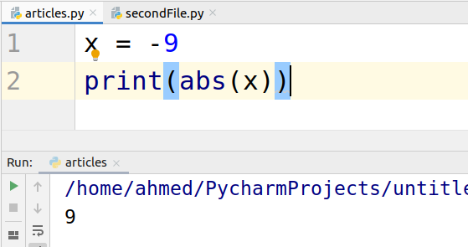

### Distance example

The take a look at the distance formula. If we take the absolute value of the difference then we

Don’t need to take the square and then square root.

|  |
| --- |
| point1 = [4, 0] point2 = [6, 6] dist = ((point1[0]-point2[1]))+((point1[0]-point2[1]))  print(dist) print(abs(dist)) |

The output is as follows.

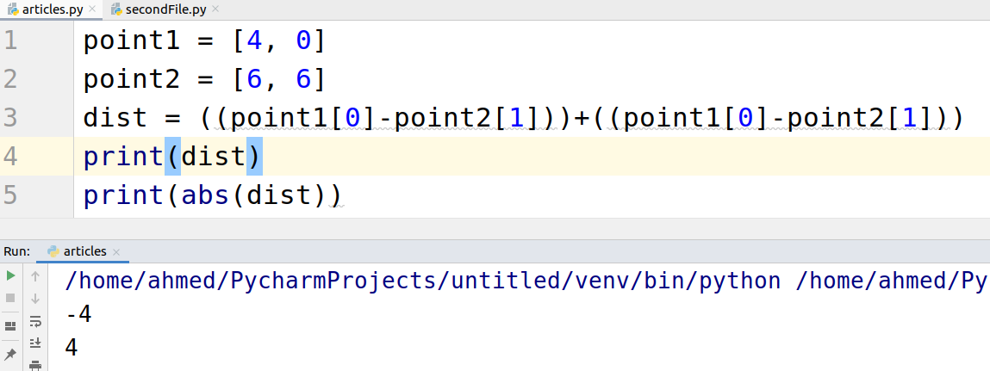

### Complex number examples

To find the magnitude of a complex number absolute function can be used. Let’s take a look at an example.

|  |
| --- |
| complex_num = 5 - 5j print(complex_num) print(abs(complex_num))  complex_num2 = 7 + 4j print(complex_num2) print( abs(complex_num2)) |

